07th March 2017

**YOKOHAMA to Launch “iceGUARD iG65” New Stud Tyre for Passenger Cars in Russia and Northern Europe**

YOKOHAMA announced today that it will begin sales of “iceGUARD iG65”, a new studded tyre for passenger cars in Russia and northern Europe, from this autumn. The new tyre will be targeted for use primarily on premium cars, with a total of 29 sizes available, from 245/40R18 97T XL to 215/65R16 102T XL.   
  
The “iceGUARD iG65” – a state-of-the-art studded tyre that delivers the ultimate performance on icy surfaces – offers drivers in Russia and northern Europe greatly improved tyre performance on the surface that challenges them the most, ice. The new “iceGUARD iG65” is based on an earlier “iceGUARD” tyre, the “iceGUARD iG55”, which was highly regarded for its exceptional ice performance and stud retention. The new tyre has a greater number of studs and a new stud-hole allocation that places studs at the center of the tyre’s tread, thus greatly enhancing its ice performance. Performance on all surfaces, including on snow and on wet and dry surfaces, has also been improved.   
  
The “iceGUARD” series is YOKOHAMA’s global winter tyre brand. The studless “iceGUARD iG50” is currently sold in North America and Asia, as well as in northern Europe and Russia.

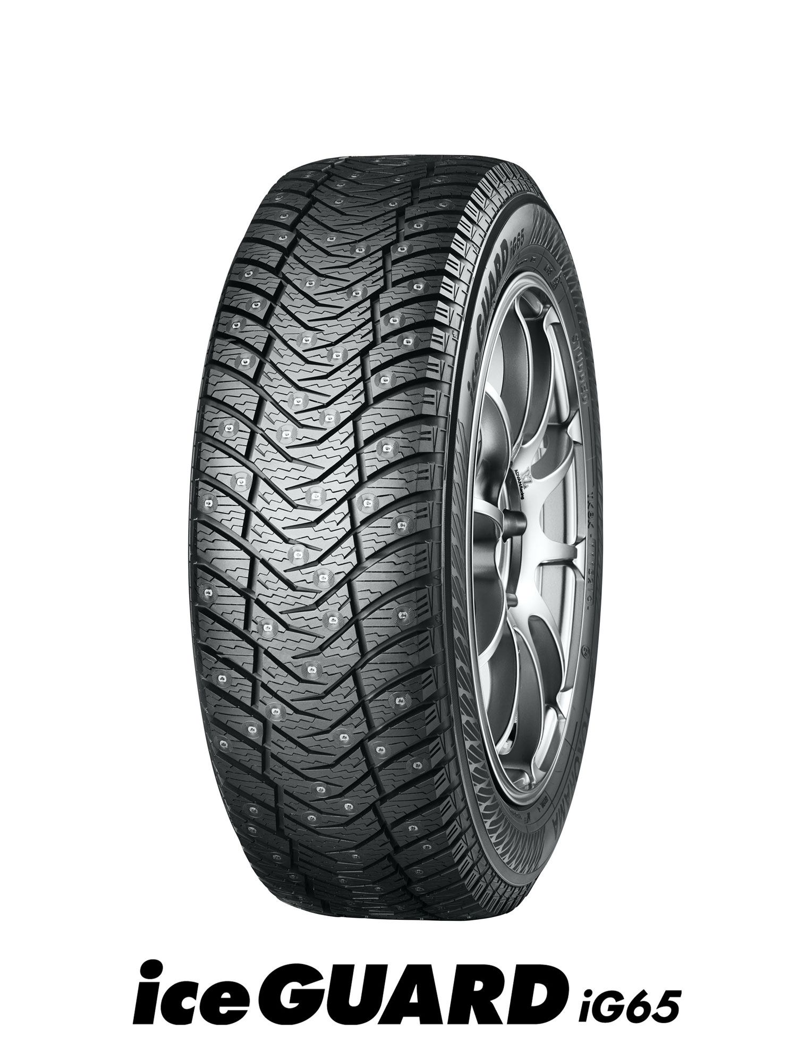

*iceGUARD iG65*